BACKUP DATABASE MANUALLY

STEP 1:

* Login to server and fire command su postgres
* Check database list

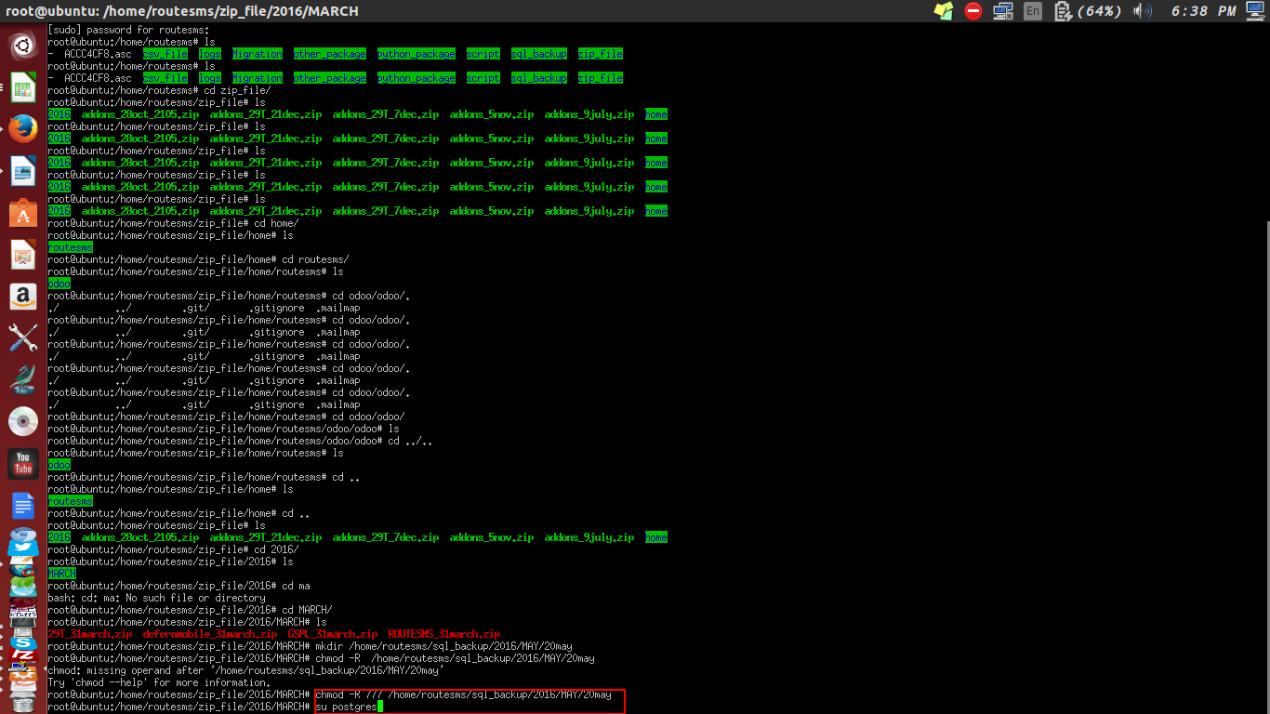

STEP 2 :

* Fire sql query “pg_dump database_name >/path/database_name.sql”

